INTEGRATIVE COURSE IN PSYCHOLOGY (ICOPSYCH)

ANALYSIS ON THE RESULT OF POST-TEST EXAMINATION IN PSYCHOLOGICAL ASSESSMENT
MAY 10, 2025

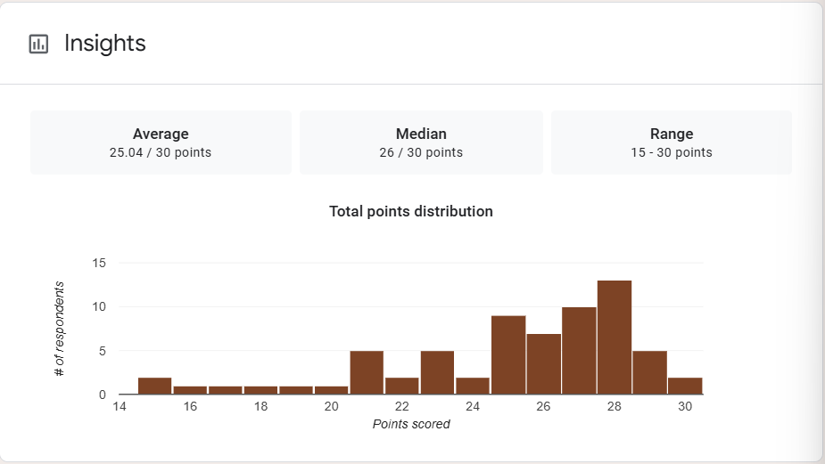

1. Mean Score: The mean score of 25.04 out of 30 equates to about 83.5%, indicating that, on average, students performed very well on the exam. This suggests strong understanding of the material and/or effective instruction.

2. Median Score: The median score is 26 (≈86.7%), slightly higher than the mean. This indicates a slight negative skew, where most students scored high, but a few lower scores slightly brought down the average.

3. Range: This range indicates a moderate level of variation, with even the lowest scores being relatively decent, and many students achieving near-perfect results.

Interpretation Summary:

-The average score (83.5%) and median (86.7%) suggest high overall achievement.

-The slight negative skew implies most students performed well, with a few lower scores pulling the mean down a bit.

-The score range (15–30) shows some variability, but even the lowest performers reached at least 50%.

-Overall, the exam results demonstrate strong student performance, with consistent understanding across most of the group, and minimal need for academic intervention.

RATIONALIZATION:

DIFFICULT QUESTIONS:

